**Evaluating the electrical performance of helium ion beam-irradiated monolayer MoS2 field effect transistors with varying exposure area**

Jakub Jadwiszczak,1,2,3 Darragh Keane,2,3,4 Conor P. Cullen,2,3,4 Pierce Maguire,1,2,3 Georg S. Duesberg2,3,4,5 and Hongzhou Zhang1,2,3,a)

1*School of Physics, Trinity College Dublin, Dublin 2, Ireland.*

2*Centre for Research on Adaptive Nanostructures and Nanodevices, Trinity College Dublin, Dublin 2, Ireland.*

3*Advanced Materials and BioEngineering Research Centre, Trinity College Dublin, Dublin 2, Ireland.*

4*School of Chemistry, Trinity College Dublin, Dublin 2, Ireland.*

**250 word abstract, 3500 word paper, 200 words per figure, 13 words per table**

One morning, when Gregor Samsa woke from troubled dreams, he found himself transformed in his bed into a horrible vermin. He lay on his armour-like back, and if he lifted his head a little he could see his brown belly, slightly domed and divided by arches into stiff sections. The bedding was hardly able to cover it and seemed ready to slide off any moment. His many legs, pitifully thin compared with the size of the rest of him, waved about helplessly as he looked. "What's happened to me?" he thought. It wasn't a dream. His room, a proper human room although a little too small, lay peacefully between its four familiar walls. A collection of textile samples lay spread out on the table - Samsa was a travelling salesman - and above it there hung a picture that he had recently cut out of an illustrated magazine and housed in a nice, gilded frame. It showed a lady fitted out with a fur hat and fur boa who sat upright, raising a heavy fur muff that covered the whole of her lower arm towards the viewer. Gregor then turned to look out the window at the dull weather. Drops of rain could be heard hitting the pane, which made him feel quite sad. "How about if I sleep a little bit longer and forget all this nonsense", he thought, but that was something he was unable to do because he was used to sleeping on his right, and in

_____________________________

1. **Author to whom correspondence should be addressed. Electronic mail: hozhang@tcd.ie.**

**Layered two-dimensional (2D) semiconductors have emerged in recent years as promising candidates for low-power miniaturized electronics. In particular, transition metal dichalcogenides (TMDs) such as MoS2 and WSe2 have demonstrated impressive ON/OFF ratios (~ 107) while maintaining relatively high field effect mobilities (tens of cm2 V-1 s-1) in two-terminal devices1–5. With chemical vapor deposition (CVD) techniques now allowing reliable millimeter-scale fabrication of well-performing monolayer TMD films6–9, it becomes crucial to understand the role of defects such as chalcogen vacancies and grain boundaries on the electrical transport properties of these materials. Moreover, the introduction of defects into TMD field effect transistors (FETs), may serve to improve charge transport if done controllably10–12.**

**Recently, noble gas ion beam irradiation has opened the field to exploring the effects of structurally modifying TMD devices on the nanometer scale13–17. The localized formation of defects by ion irradiation has been shown to induce unusual electronic properties in monolayer TMDs, such as pseudo-metallic phase transitions in MoS2,WSe2 and WS218–20. Such ion beam techniques are known to preferentially sputter sulfur from MoS­2 while retaining a structural integrity for on-substrate flakes18,21,22­. The formed sulfur vacancies (SVs) can then act as donors in the FET channel, and in the absence of a readily oxidising species (such as during oxygen plasma treatment) they will shift the threshold voltage (Vth) of the FET to higher negative biases11,23,24. A recent theoretical study has shown that the formation of a dislocation-divacancy complex will lead to significant n-type doping in defective MoS225. These states can then form stable impurity bands near the conduction band and improve carrier mobility26. A zero-sum game between the concentration of effective donors vs scattering potentials from vacancies needs to be played out for optimum tuning of carrier transport in TMDs27–30. As the spread of the typical focused He ion probe is several nanometers, it is reasonable to expect not only S sputtering, but also the formation of other defects in the irradiated 2D lattice31,32. The deep n-type doping behavior hence achieved by ion sputtering will depend not only on the dose of the ion beam necessary for optimal defect formation, but the concentration of such defects that can be introduced by the beam. This directly translates to the area of the channel which is being irradiated, on which we focus our attention in this letter.**

**Monolayer MoS2 samples were grown onto 285 nm SiO2/Si substrates by a CVD method described in previous work {REF}. The resulting flakes were usually triangular in shape with a good concentration of isolated samples present on the substrate due to this growth method. A representative scanning electron micrograph (Zeiss Supra) is shown in Fig. 1(a). Electron beam lithography was then used to contact isolated flakes with 5 nm Ti/35 nm Au electrodes. All FET channels fabricated for this work had a width of 5 µm. The electrodes were deposited in a geometry perpendicular to the edge of the MoS2 triangles, as to avoid any transport anisotropy resulting from crystal orientation29,33,34. Some channels were fabricated on the same MoS2 flake. An optical micrograph of a typical contacted device is presented in Fig. 1(b). The metal film was lifted off in acetone overnight, and the devices were not annealed prior to electrical testing. Characterization was carried out in the vacuum chamber of a customized scanning electron microscope (Zeiss EVO), after devices were pumped at a pressure of ~ 10-5 mbar for 12 hours. Imina miBot probes were used to contact the device to a dual channel sourcemeter (Agilent BX). The FETs were back-gated through the highly p-doped Si substrate attached to copper tape. Raman and photoluminescence spectroscopy was carried out to determine the quality and layer number of the tested samples. The spectra were acquire at x using a WiTEC x system at 532 nm with grating blabla. Typical spectra of the monolayer flakes are presented in Fig. 1(c)-(d). The separation of the E and A modes is in good agreement for literature numbers for single layer MoS2 {REF}. The PL emission is strongly centred at 1.85 eV, indicating the direct-recombination peak of monolayer MoS2 {REF}.**

**Helium ion irradiation was carried out in a Zeiss Nanofab microscope at a beam energy of 30 keV and He gas pressure of 2 × 10-6 mTorr. The average beam current (aperture 20 µm) was 37.47 ± 0.38 pA, with the minimum probe size evaluated at 7 nm (see supplementary material in (ref Fox) for details on evaluation of probe size. The He ion dose delivered to each sample was 1017 ions cm-2, with a probe step size of 1 nm and dwell time of 4.3 µs. The irradiation patterns were draw on the Zeiss ZEN software, with the beam only scanning in one direction (parallel to the electrodes) throughout the patterning process. Figure 2(a) shows a sketch of the experimental geometry. The as-made MoS2 FETs were placed in the helium ion microscope after initial electrical testing and were all irradiated within the same day without leaving vacuum, with the stage tilt set at 0º. Ion exposure to the devices was minimal before commencing irradiation (limited to the quick image grab dose which is ~ 5 orders of magnitude less than the working dose). A focused probe was obtained away from the MoS­­2 devices to reduce unnecessary exposure. A typical SEM micrograph of an irradiated device is presented in Fig. 2(b). The marked distances and denote the width of the irradiated region and length of the FET channel respectively. L was always 5 µm in this work, while was varied in order to obtain a damage-to-channel ratio, . Following the patterning and electrical testing, the devices were analyzed in the SEM. As the chosen dose will inevitably lead to damage extension past the designed region, the true irradiated area of the channel was measured and divided by the true area of the channel. This ensures a highly accurate ratio of the beam-damaged MoS­­2 material. Thus, when referring to the irradiation ratio in the rest of the manuscript, ,we will mean this true ratio obtained post-experiment.**

**The typical effect of irradiating the MoS2 sample at the dose of 1017 ions cm-2 is shown in Figure 2(c). Just as in our previous work18, this high dose causes a notably higher electrical conduction to emerge in the monolayer MoS­2, with output current (green) increasing ~ 5-fold for the same drain-source bias when compared to the as-made device (blue). The post-irradiation transfer characteristics (green), in turn, reveal a much-reduced response to changes in the gate bias. The nominally semiconducting FET channel cannot now be effectively turned off in the tested bias range, with significant current still present at . This is in stark contrast to the n-type device behavior noted for the MoS­2 channel pre-irradiation (blue). The sharp rise in the subthreshold swing and the huge shift of the threshold voltage to negative gate biases experienced by the device may have several origins. The presence of the metallic 1T-MoS2 phase results in no gate tunability35–37, while our device retains a small ON-OFF ratio of ~ 40. MoS2 samples rich in sulfur vacancies have been shown to also possess a decreased sensitivity to gate voltage11,38. Notably, low-energy and low-dose Ar+ ion irradiation has demonstrated a similar effect on the gating characteristics of MoS2, but the effect was to reduce the conductance of the sample and shift Vth to positive biases with increasing ion fluence23.**

**Figures 3(a)-(b) present the IV and gate curves of irradiated monolayer MoS2 FETs with a different (expressed as percentages) delivered at the same ion dose and energy. The effects of varying are evident from the changes in the output and transfer characteristics in Figs. 3(a)-(b), with the curves roughly separated into 3 groups (marked by blue, green and red color shades). The IV curves, taken at , demonstrate a clear drop in conductance of the device with increasing . The blue shade curves represent the relatively small ratio of irradiated-to-channel area (7-18%), where the FET experiences severe V­th shifting to negative biases and low ON/OFF ratio as seen in Fig. 3(b). As is increased into the green (28-41%) and red (48-76%) groups, the device conductance drops while the ON/OFF ratio is also seen to decrease roughly exponentially. This is clearly demonstrated in Figure 3(c), which tracks the relationship of the log-transformed ON/OFF ratio as a function of . A good linear correlation is found (R = -0.85), indicating the exponential dependence of the ON/OFF ratio on .**

**Figure 3(d) reveals the effect of on the change in the field effect mobility, , of the device relative to its as-made mobility, . Extracted from the active region of the FET, the mobility is in fact seen to improve by up to a factor of 0.4 in 2 out of 3 devices in the blue region. For the green and red regions of , the mobility is always seen to worsen, sometimes even by up to 100%, as the area of the irradiated channel is increased. The recorded observations are in line with expected results. As the area of the damaged MoS2 region relative to that which is left as-made is increased, the carrier mobility is expected to drop heavily as the rate of scattering will rise with increasing area of defective material. The improved mobility in the case of small may be explained due to the formation of. Further low-temperature transport studies will help to elucidate the exact mechanism of this improvement. As irradiating the whole channel at this dose has previously resulted in increased conductivity18, it may be crucial to consider the ratio of the pristine-to-damaged area in terms of channel asymmetry relative to the electrodes.**

**One consideration of such asymmetry is to irradiate similar areas of the channel in two devices, such that an electrode suffers ion beam damage only for one case, and compare. Fig. 4 presents three sets of data for the different regimes, where a similar area of the channel has been irradiated on each device. However, for one of the devices, a single electrode was also irradiated at the same dose to introduce the above-mentioned asymmetry. The accompanying SEM images in Fig. 4 show the beam-damaged areas in green and the untouched MoS2 areas in red. The electrode-touching case (labeled T in the plots), is framed in green in each set, while the not-touching case (labeled NT in the plots) is framed in purple. In all three cases, allowing one of the electrodes to be damaged by the beam leads to a larger drop in the channel conductance than in the case of MoS2-only damage. The gate curves in Figs. 4(b),(d), (f) indicate that as the device approaches the strong inversion regime at high gate biases, the increased area of damage coupled with electrode interface damage (green) inhibits high ON currents for the transistor relative to the case of no electrode damage (purple).**

**Naturally, as the beam introduces damage both into the electrode and MoS2 underneath the contact interface, it may be expected that a rise in the Schottky barrier height will occur if the usually-pinned Fermi level39 is now a function of the beam-altered metal-semiconductor interface. Pre-treating with a low-energy broad beam Ar+ source has been employed previously to decrease the contact resistance of nickel to MoS­2, due to the increased concentration of dangling bonds available for hybridization when the contact is deposited40. As we are treating an already-hybridized interface, we suspect that the formation of defects will serve to trap carriers at the interface and will reduce the injection current at the contact. This may be further confirmed with a combination of low-temperature electrical characterization and capacitance measurements41,42 in future work.**

**In conclusion, we have studied the effect of varying the irradiated channel area of helium ion-treated monolayer MoS2 FETs. We have demonstrated that introducing a small concentration of defects into the material (< 10% of irradiated-to-channel area) can serve to improve the carrier mobility and channel conductance. Devices with a larger irradiated area suffered an increasing drop in the conductance of the channel and associated field effect mobility of carriers relative to the as-made material. This is a direct consequence of the increased concentration of defects present in the MoS2 channel due to ion-induced sputtering. In addition, the effect of irradiating one of the device electrodes was compared across three different irradiation-to-channel area ratios. The effect of damaging the electrode was deleterious on the performance of the FET, with a larger conductance drop noticed for the same area of channel irradiation. Our work demonstrates that by tuning the irradiation strategy and localizing the damage to specific sites, the electronic characteristics of MoS2 FETs can be well-controlled in the monolayer limit.**

**See supplementary material for information on…**

**The authors acknowledge the staff at the Advanced Microscopy Laboratory, Trinity College Dublin, for continuing assistance with the HIM and SEMs. This work was performed under financial support from…**

1 D. Jariwala, V.K. Sangwan, D.J. Late, J.E. Johns, V.P. Dravid, T.J. Marks, L.J. Lauhon, and M.C. Hersam, Appl. Phys. Lett. **102**, 2 (2013).

2 B.W.H. Baugher, H.O.H. Churchill, Y. Yang, and P. Jarillo-Herrero, Nano Lett. **13**, 4212 (2013).

3 G. V. Resta, S. Sutar, Y. Balaji, D. Lin, P. Raghavan, I. Radu, F. Catthoor, A. Thean, P.-E. Gaillardon, and G. de Micheli, Sci. Rep. **6**, 29448 (2016).

4 L. Cai, C.J. McClellan, A.L. Koh, H. Li, E. Yalon, E. Pop, and X. Zheng, Nano Lett. **17**, 3854 (2017).

5 C. Li, X. Yan, W. Bao, S. Ding, D.W. Zhang, and P. Zhou, Appl. Phys. Lett. **111**, 193502 (2017).

6 A. Allain, J. Kang, K. Banerjee, and A. Kis, Nat. Mater. **14**, 1195 (2015).

7 K. Kang, K.-H. Lee, Y. Han, H. Gao, S. Xie, D.A. Muller, and J. Park, Nat. Publ. Gr. **550**, (2017).

8 X. Song, W. Zan, H. Xu, S. Ding, P. Zhou, W. Bao, and D.W. Zhang, **25051**, (n.d.).

9 H. Bergeron, V.K. Sangwan, J.J. Mcmorrow, G.P. Campbell, I. Balla, X. Liu, M.J. Bedzyk, T.J. Marks, and M.C. Hersam, Cit. Appl. Phys. Lett **110**, (2017).

10 Z. Lin, A. McCreary, N. Briggs, S. Subramanian, K. Zhang, Y. Sun, X. Li, N.J. Borys, H. Yuan, S.K. Fullerton-Shirey, A. Chernikov, H. Zhao, S. McDonnell, A.M. Lindenberg, K. Xiao, B.J. LeRoy, M. Drndić, J.C.M. Hwang, J. Park, M. Chhowalla, R.E. Schaak, A. Javey, M.C. Hersam, J. Robinson, and M. Terrones, 2D Mater. **3**, 42001 (2016).

11 J. Jadwiszczak, C. O’Callaghan, Y. Zhou, D.S. Fox, E. Weitz, D. Keane, C.P. Cullen, I. O’Reilly, C. Downing, A. Shmeliov, P. Maguire, J.J. Gough, C. McGuinness, M.S. Ferreira, A.L. Bradley, J.J. Boland, G.S. Duesberg, V. Nicolosi, and H. Zhang, Sci. Adv. **4**, eaao5031 (2018).

12 I.S. Kim, V.K. Sangwan, D. Jariwala, J.D. Wood, S. Park, K.-S. Chen, F. Shi, F. Ruiz-Zepeda, A. Ponce, M. Jose-Yacaman, V.P. Dravid, T.J. Marks, M.C. Hersam, and L.J. Lauhon, **8**, 10551 (2014).

13 L. Madauß, O. Ochedowski, H. Lebius, B. Ban-d’Etat, C.H. Naylor, A.T.C. Johnson, J. Kotakoski, and M. Schleberger, 2D Mater. **4**, 15034 (2016).

14 V. Iberi, L. Liang, A. V Ievlev, M.G. Stanford, M. Lin, X. Li, M. Mahjouri-samani, S. Jesse, B.G. Sumpter, S. V Kalinin, D.C. Joy, K. Xiao, A. Belianinov, and O.S. Ovchinnikova, Nat. Publ. Gr. 1 (2016).

15 M.G. Stanford, B.B. Lewis, K. Mahady, J.D. Fowlkes, and P.D. Rack, J. Vac. Sci. Technol. B, Nanotechnol. Microelectron. Mater. Process. Meas. Phenom. **35**, 30802 (2017).

16 M.G. Stanford, P.R. Pudasaini, N. Cross, K. Mahady, A.N. Hoffman, D.G. Mandrus, G. Duscher, M.F. Chisholm, and P.D. Rack, Small Methods 1600060 (2017).

17 J. Klein, A. Kuc, A. Nolinder, M. Altzschner, J. Wierzbowski, F. Sigger, F. Kreupl, J.J. Finley, U. Wurstbauer, A.W. Holleitner, and M. Kaniber, (2017).

18 D.S. Fox, Y. Zhou, P. Maguire, A. O’Neill, C. Ó’Coileáin, R. Gatensby, A.M. Glushenkov, T. Tao, G.S. Duesberg, I. V Shvets, M. Abid, M. Abid, H.-C. Wu, Y. Chen, J.N. Coleman, J.F. Donegan, and H. Zhang, Nano Lett. **15**, 5307 (2015).

19 M.G. Stanford, P.R. Pudasaini, A. Belianinov, N. Cross, J.H. Noh, M.R. Koehler, D.G. Mandrus, and G. Duscher, Nat. Publ. Gr. 1 (2016).

20 M.G. Stanford, P.R. Pudasaini, E.T. Gallmeier, N. Cross, L. Liang, A. Oyedele, G. Duscher, M. Mahjouri-Samani, K. Wang, K. Xiao, D.B. Geohegan, A. Belianinov, B.G. Sumpter, and P.D. Rack, Adv. Funct. Mater. **27**, 1702829 (2017).

21 Quan, J. Phys. Condens. Matter **25**, (2013).

22 Z. Li and F. Chen, Appl. Phys. Rev. **4**, (2017).

23 S. Bertolazzi, S. Bonacchi, G. Nan, A. Pershin, D. Beljonne, and P. Samorì, Adv. Mater. 1606760 (2017).

24 H. Qiu, T. Xu, Z. Wang, W. Ren, H. Nan, Z. Ni, Q. Chen, S. Yuan, F. Miao, F. Song, G. Long, Y. Shi, L. Sun, J. Wang, and X. Wang, Nat. Commun. **4**, (2013).

25 Z.G. Yu, Y.-W. Zhang, and B.I. Yakobson, (n.d.).

26 V.K. Sangwan and M.C. Hersam, Annu. Rev. Phys. Chem. Annu. Rev. Phys. Chem **6912**, (2018).

27 S.-L. Li, E. Orgiu, P. Samorì, K. Tsukagoshi, and P. Samor, Chem. Soc. Rev. Chem. Soc. Rev **45**, 1 (2016).

28 Y. Yoon, K. Ganapathi, and S. Salahuddin, (2011).

29 S. Najmaei, M. Amani, M.L. Chin, Z. Liu, A.G. Birdwell, T.P. Oregan, P.M. Ajayan, M. Dubey, and J. Lou, ACS Nano **8**, 7930 (2014).

30 K. Kaasbjerg, T. Low, and A.-P. Jauho, 55 (2016).

31 J. Buchheim, R.M. Wyss, I. Shorubalko, and H.G. Park, Nanoscale **8**, 8345 (2016).

32 K. Yoon, A. Rahnamoun, J.L. Swett, V. Iberi, D.A. Cullen, I. V Vlassiouk, A. Belianinov, X. Sang, O.S. Ovchinnikova, A.J. Rondinone, R.R. Unocic, and A.C.T. Van Duin, (2016).

33 M. Ghorbani-Asl, A.N. Enyashin, A. Kuc, G. Seifert, and T. Heine, Phys. Rev. B **88**, 245440 (2013).

34 L. Peng, S.A. Wells, C.R. Ryder, M.C. Hersam, and M. Grayson, Phys. Rev. Lett. **120**, 86801 (2018).

35 S. Kim, (2016).

36 D. Marian, E. Dib, T. Cusati, E.G. Marin, A. Fortunelli, G. Iannaccone, and G. Fiori, Phys. Rev. Appl. **8**, 1 (2017).

37 N. Papadopoulos, G.A. Steele, and H.S.J. van der Zant, Phys. Rev. B **96**, 235436 (2017).

38 J. Zhu, Z. Wang, H. Yu, N. Li, J. Zhang, J. Meng, M. Liao, J. Zhao, X. Lu, L. Du, R. Yang, D. Shi, Y. Jiang, and G. Zhang, J. Am. Chem. Soc. jacs. 7b05765 (2017).

39 C. Kim, I. Moon, D. Lee, M.S. Choi, F. Ahmed, S. Nam, Y. Cho, H. Shin, S. Park, and W.J. Yoo, ACS Nano acsnano.6b07159 (2017).

40 Z. Cheng, J.A. Cardenas, F. McGuire, and A.D. Franklin, IEEE Electron Device Lett. **7**, in review (2015).

41 B.H. Moon, G.H. Han, H. Kim, H. Choi, J.J. Bae, J. Kim, Y. Jin, H.Y. Jeong, M.-K. Joo, Y.H. Lee, and S.C. Lim, ACS Appl. Mater. Interfaces acsami.6b16692 (2017).

42 H.-J. Kim, D.-H. Kim, C.-Y. Jeong, J.-H. Lee, and H.-I. Kwon, IEEE Electron Device Lett. **1**, 1 (2017).

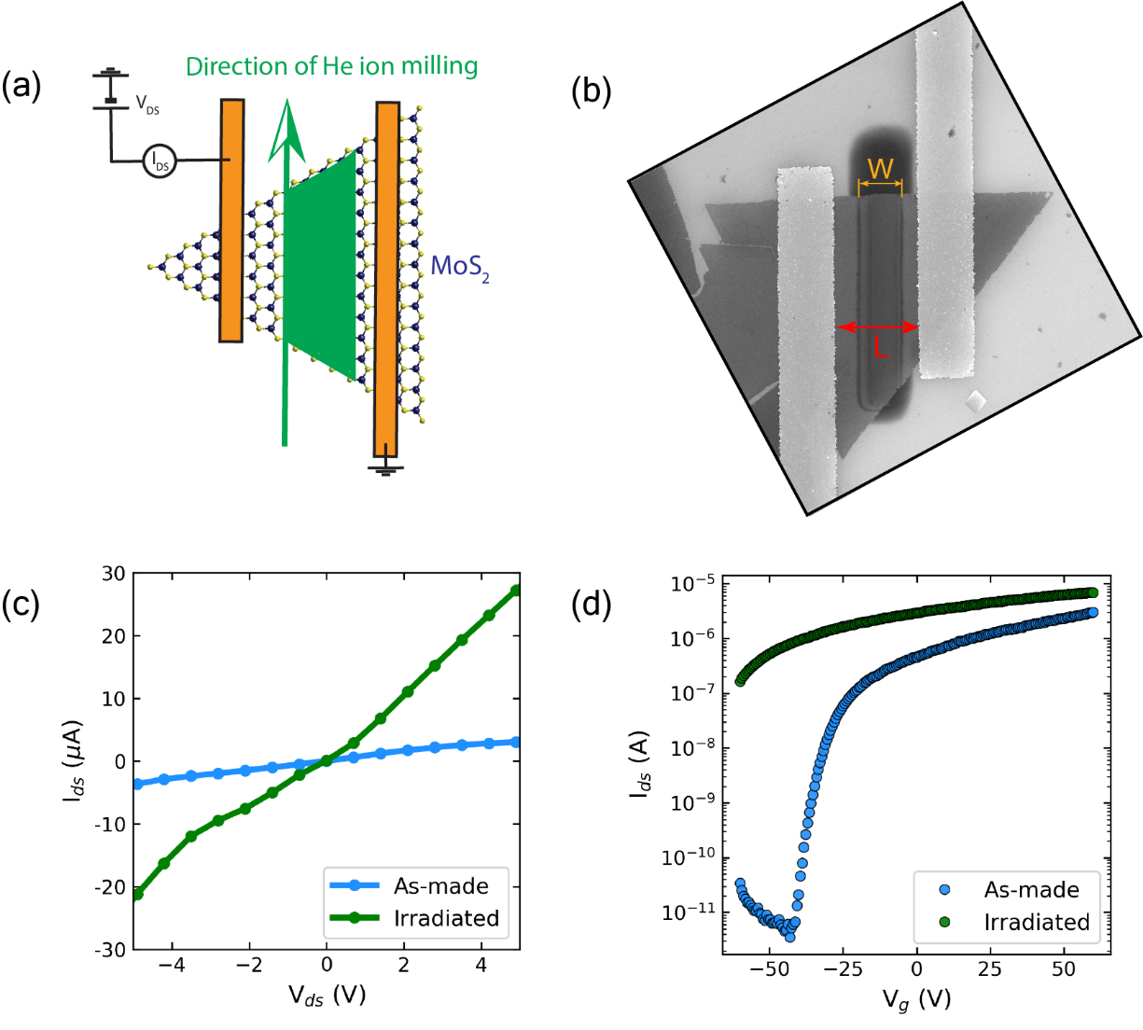

**FIG. 2.** (a) Sketch demonstrating the irradiation strategy on contacted monolayer MoS2 devices. The green area marks the designed damaged area. (b) SEM image of a post-irradiation device. marks the width of the damaged region, while is the length of the FET channel. is 5 µm in the image. (c) Typical IV curve of a device post-irradiation (corresponding to ). (d) Gate curve of the same device demonstrating behavior after He ion irradiation.

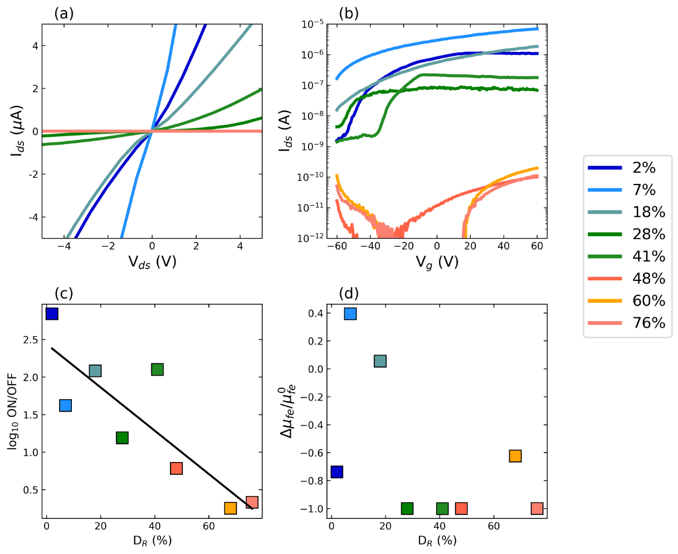

**FIG. 3.** Effects of irradiation-to-channel area, , on the characteristics of the MoS2 FET.  **Note that all the plots share the same color legend on the right.** (a) IV and (b) gate sweeps of different devices with varying. (c) Semi-log plot of the extracted device ON/OFF ratios corresponding to each gate curve in (b). The black line is a linear fit to the data. (d) Change in the field effect mobility relative to as-made devices extracted from transfer curves in (b).

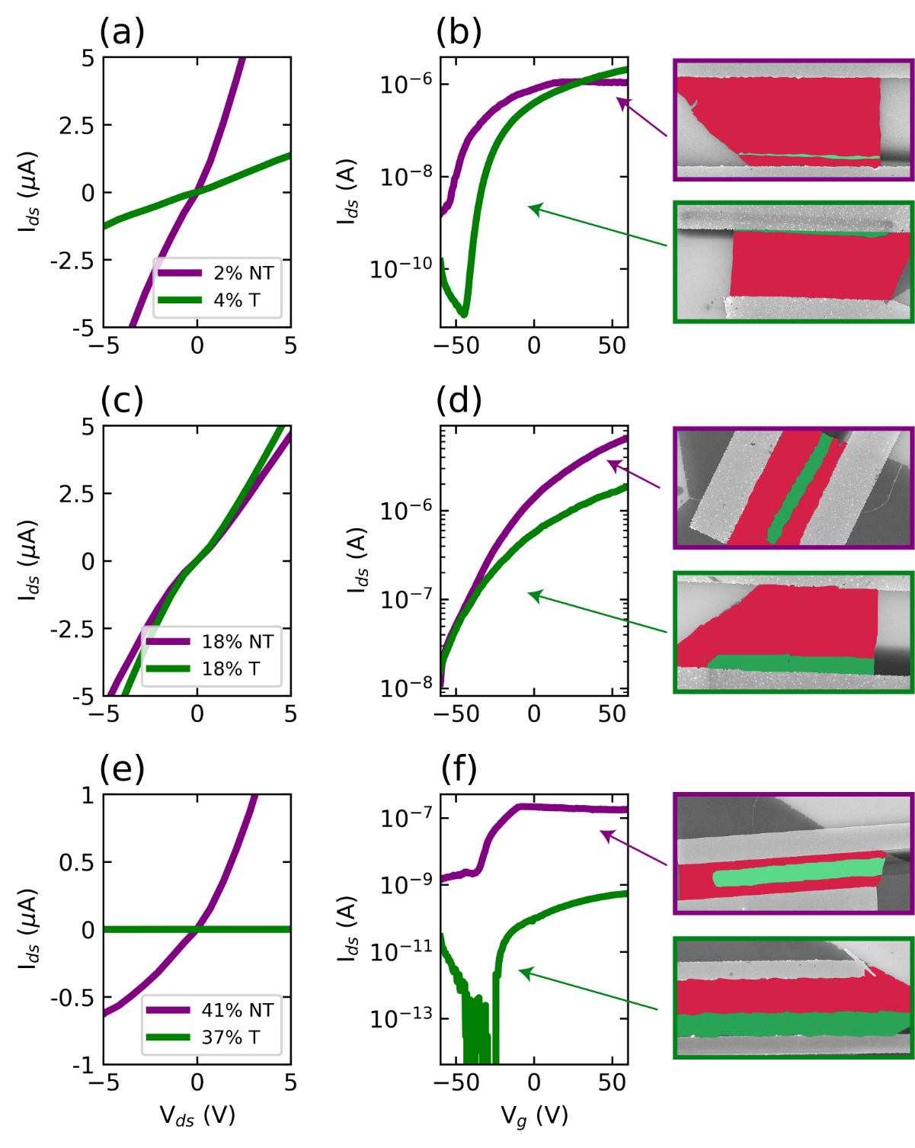

**FIG. 4.** Comparison of IV and gate curves for devices with a similar where the electrode has not been irradiated (purple curves and picture frames), and where one electrode has been irradiated (green curves and picture frames). (a) & (b) present the IV and gate curves respectively, with the SEM of each device linked to the curves. The green area in the SEM images is the area damaged by the He ion beam, while the red area is the left over as-made MoS2 channel. Electrode-to-electrode distance in each image is 5 µm.